Experiment 7: App Layout Creation using GIMP
SAILOO S
23070277
Aim:
To create and analyze an e-commerce app homepage layout using GIMP, focusing on structured sections, visual balance, typography, and color dynamics to deliver a realistic shopping experience.

Tools Used:
GIMP (GNU Image Manipulation Program
Procedure:
Step 1: Install GIMP
- Download and install GIMP from the official website.
Step 2: Create a New Project
- Open GIMP and set up a new canvas with dimensions suitable for web (standard dimensions around 1200x800 pixels were used).
Step 3: Designing the Layout
- Header Section:
  - Created a horizontal bar at the top.
  - Added the brand name "NOUS" on the left side using the Text Tool, simulating a typical brand logo placement.
  - On the right side, navigation links were inserted: "SHOP ALL," "ABOUT," and "CONTACT," maintaining simplicity and readability.
  - A small "greater than" (>) sign was added to imply additional navigation options.
- Promotional Banner:
  - Below the header, a bold, eye-catching red banner was created.
  - Inserted the text "FREE SHIPPING" prominently in the center with a contrasting white font to ensure high visibility.
- Category Section:
  - Directly under the red banner, another horizontal section was added.
  - This section was divided into three clickable category links: "WOMEN CLOTHING," "MEN CLOTHING," and "KID CLOTHING," spaced evenly across the width.
- Product Display Section:
  - The lower half of the layout was split into two image sections.
  - Left side: Featured two models wearing hoodies, representing the "WOMEN" and "MEN" clothing categories.
  - Right side: Featured a close-up shot of another model in kid-friendly clothing, emphasizing a premium yet casual look.
Step 4: Add UI Elements and Styling
- All text was added using the Text Tool.
- Fonts were chosen to be modern and sans-serif to maintain a clean, sleek aesthetic.
- Used high-resolution images to maintain professional visual quality.
- All sections were aligned symmetrically to balance the visual flow.
Step 5: Organize Layers
- Each UI component (logo, navigation, banner, categories, images) was placed on separate layers.
- Layer naming conventions were followed for easier edits (e.g., "Header Text," "Banner Background," "Product Image 1").
Step 6: Experiment with Color Schemes
- Main colors:
  - White (background) for cleanliness.
  - Red (promotional banner) for urgency and attention.
  - Black (clothing) to convey luxury and simplicity.
- This minimalistic color scheme enhances focus on the products and promotional elements.
Step 7: Export Final Design
- The final layout was exported in PNG format for maximum compatibility and quality.

Output Screenshot:
Designed Layout Screenshot:
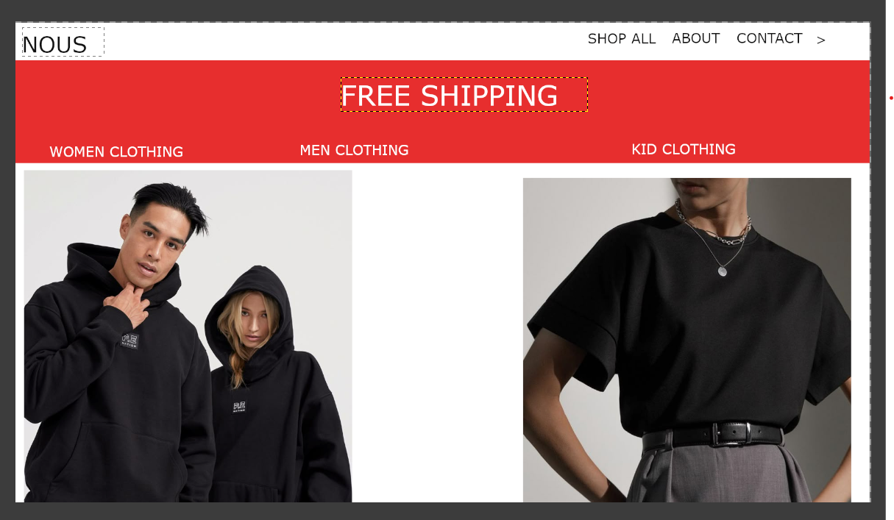
Observations and Detailed Analysis:
- Brand Identity: Clear and simple brand representation with the "NOUS" logo.
- Navigation: Minimal and direct, enhancing user experience without overwhelming them.
- Visual Hierarchy:
  - "FREE SHIPPING" banner strategically positioned for immediate user attention.
  - Category labels placed logically right below to guide users swiftly.
- Product Presentation:
  - Two models featured on the left, with casual, relatable poses enhance approachability.
  - Solo model on the right with a clean, modern outfit gives a sophisticated vibe.
- Color Impact:
  - The use of red contrasts against the white background to create urgency.
  - Black outfits balance the red, providing a grounded, professional look.
- Usability:
  - Clear sections allow users to intuitively navigate between shopping categories.
  - Visual simplicity reduces cognitive load.
Conclusion:
This experiment successfully recreated a professional and appealing shopping homepage using GIMP. By thoughtfully structuring layout elements and choosing a restrained but powerful color palette, the design ensures excellent usability and visual engagement. GIMP proved to be an effective and accessible tool for rapid UI/UX prototyping, demonstrating its capabilities beyond just image editing.

